National College of Ireland
Module: Distribution Systems
Student Name: Dawid Nowak
Student ID: x24235822
Programme: Higher Diploma in Computer Science
GitHub Repository:
https://github.com/DawidNowak2025/ca-distributed-systems
Introduction
For this assignment in Distributed Systems module, I had to design and build my own project. I decided to choose topic related to United Nations goal called Affordable and Clean Energy, because it looks more practical and closer to real life. I think this topic is interesting because many people now use solar panels and batteries in homes, so it is something real, not only theory.
This project is not real system, it is only simulation. I am not building something that can be connected to real solar panel. The goal was to understand how distributed systems work, how services communicate and how data can be passed between them. At the beginning it was a bit confusing, especially how gRPC works, I did not understand it fully at first, but later it started to make more sense.I tried to keep system not too complicated, but still showing main ideas. Distributed systems can be very complex in real life, but for this project I focused on main concepts like service communication, discovery and streaming.
Service Definitions
In my project I created four different services. Each service has its own responsibility, so they are separated from each other.
The services are:
- SolarService
- BatteryService
- EnergyService
- RegistryService
Each service is defined using Protocol Buffers (.proto files). These files define what kind of messages are used and what methods are available. It works like agreement between client and server, so both sides know what data to send.
SolarService has two methods. First one is unary, where client sends request and gets one response. Second one is server streaming, where server sends many responses over time.
BatteryService also has two methods. Unary method is used to check battery status. Client streaming method allows sending many events and getting one result at the end.
EnergyService is more advanced. It has unary method and also bidirectional streaming. This means client and server both can send messages at the same time.
RegistryService is used for service discovery. It stores information about all services in system.
Service Implementations
All services are implemented in Node.js using gRPC. Each service runs on its own port and works independently.
SolarService is quite simple. It calculates energy output using sunlight level, panel area and efficiency. I used simple multiplication for that. For streaming method, I used setInterval function, so server sends new values every second. I also added small random changes to simulate weather changes.
BatteryService was a bit more difficult. I had to store battery level in memory. When client sends events, server updates this value step by step. For example, if there is charging event, battery goes up. If there is usage event, battery goes down. At the end, server sends one summary result.
EnergyService was probably the hardest part. It works like decision system. It compares production and consumption values. Based on that, it returns recommendation. For example, if production is high, system suggests storing energy. If consumption is higher, it suggests using battery.
Bidirectional streaming in EnergyService was not easy to understand at first. Client sends data continuously, and server responds also continuously. I had to test it few times before it worked correctly.
At one point I had problem with missing shared files and proto loading, because project did not start correctly after cloning. I had to fix file structure and add missing files to make everything work properly.
Naming Services
In distributed systems it is not good idea to hardcode addresses of services. Because of that I created RegistryService.
RegistryService works like simple directory. Each service registers itself when it starts. It sends its name, host and port. Registry stores this information.
When client wants to use service, it does not connect directly. First it asks registry where service is. Then it connects using returned address.
This makes system more flexible, because services are not hardcoded and can change without breaking whole system.. If service changes port, client still can find it. It is simple solution but works well for this project.
Remote Error Handling & Advanced Features
Error handling is important part of distributed systems. If something goes wrong, system should not crash.
In my project I added validation for inputs. For example, efficiency in SolarService should be between 0 and 1. If user sends wrong value, server returns error.I used gRPC status codes to send error messages. This way client knows what went wrong.
I also used deadlines. Sometimes service may not respond, so client should not wait forever. After some time request is cancelled.
Advanced features used in project:
- unary RPC
- server streaming
- client streaming
- bidirectional streaming
I think all main communication types are covered
I tested error handling by sending wrong values from GUI, which helped me check if validation really works or not.
GUI
To make testing easier, I created simple GUI.
GUI is built using Express, HTML, CSS and JavaScript It is not very complex, but it is enough to show how system works, I did not want to overcomplicate frontend part.
User can:
- discover services
- enter values
- click buttons to call services
see resultsImportant thing is that browser does not connect directly to gRPC. Instead, it sends HTTP request to Express backend. Then backend communicates with services using gRPC.
At first I wanted to connect directly, but it was not easy in browser, so this solution worked better.
System Architecture Diagram
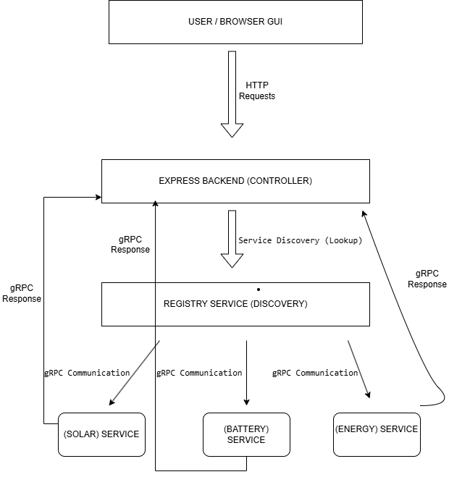Figure 1: System Architecture Diagram
The diagram shows how the Smart Clean Energy Management System is structured and how the components communicate with each other.
User interacts with the system through a browser-based GUI. The GUI sends HTTP requests to the Express backend, which acts as the main controller of the application.When the backend needs to use a service, it first contacts the RegistryService to perform service discovery. The registry returns information about available services, such as their host and port. This allows the system to avoid hardcoded addresses and makes it more flexible.
After discovering the correct service, the backend communicates with the services using gRPC. There are three main services in the system: SolarService, BatteryService and EnergyService. Each service performs a different function, such as energy production, storage or decision making.Each service processes the request and sends a response back to the backend using gRPC. The backend then forwards the result to the GUI using HTTP response. This creates a complete request–response cycle.It is important to note that the RegistryService is only used for service discovery and does not take part in the response flow between services and the client.
This architecture follows a simple distributed system design where components are separated but still work together through controlled communication.
Screenshots
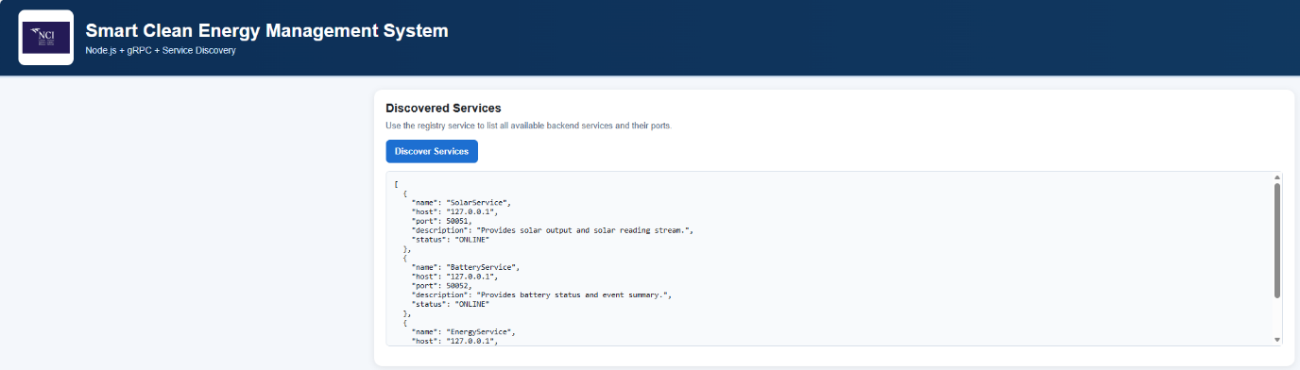Figure 2: Service Discovery using RegistryService
This screenshot shows the service discovery process. The client sends a request to the backend, which then contacts the RegistryService to retrieve a list of available services. The services are displayed with their host and port values, confirming that dynamic service discovery is working correctly
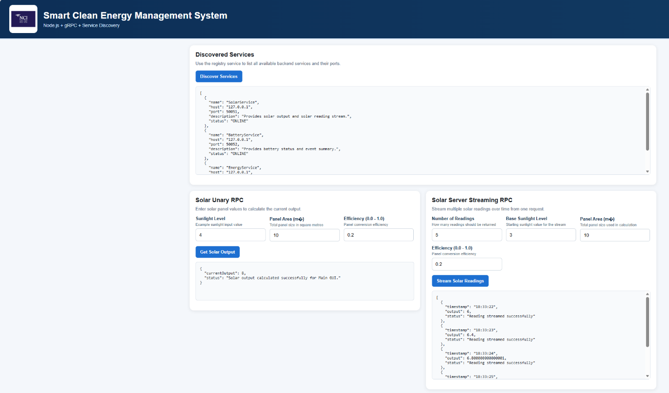Figure 3: SolarService – Unary and Streaming
This screenshot demonstrates the functionality of SolarService. The unary RPC returns a single calculated energy output based on the provided input values such as sunlight level, panel area and efficiency. The server streaming RPC shows multiple output values sent over time, simulating real-time solar energy production.
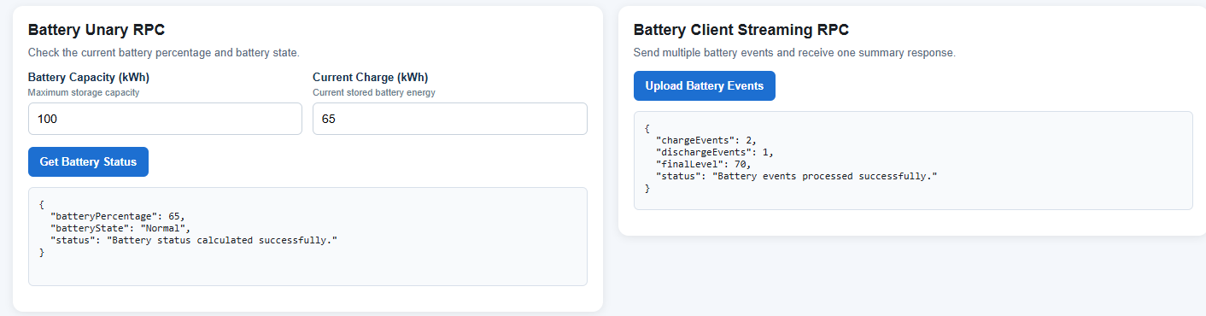Figure 4: BatteryService – Unary and Client Streaming
This screenshot presents the BatteryService operations. The unary method returns the current battery status. The client streaming method allows multiple battery events to be sent to the server, which processes them and returns a single summary result after all inputs are received.
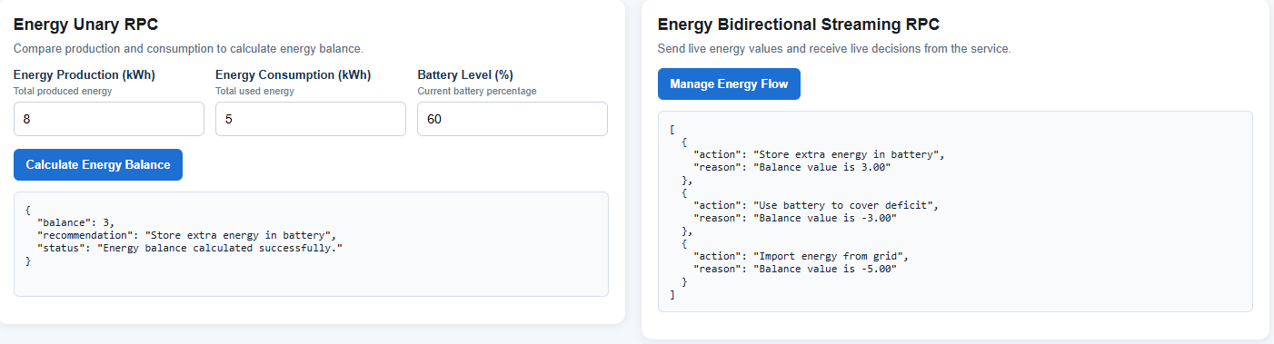
Figure 5: EnergyService – Unary and Bidirectional Streaming
This screenshot shows the EnergyService. The unary method calculates the energy balance and provides a recommendation based on production and consumption values. The bidirectional streaming demonstrates continuous communication between client and server, where both sides exchange messages in real time.
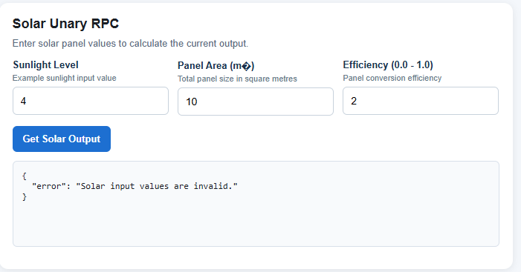
Figure 6: Error Handling Example
This screenshot shows an example of error handling in the system. When an invalid input is provided, such as an incorrect efficiency value, the service returns an error message using gRPC status codes. This confirms that validation and remote error handling are implemented correctly.
This flow was not easy to understand at first, but drawing the diagram helped me a lot.
Conclusion
This project was not easy, especially at the beginning. I had to learn new things like gRPC and Protocol Buffers, which I did not use before.

Now I understand better how distributed systems work, before this project I only knew theory, but now I see how services really communicate.
There were some problems during development, especially with errors and configuration, but fixing them helped me understand system better.
Even if this is only simulation, it shows real concepts like service discovery, streaming and error handling. I think it was good practice and helped me understand topic much better.
The project was also tested by cloning it from GitHub and running it in a clean environment, which confirmed that it works correctly.
References
Coulouris, G., Dollimore, J. and Kindberg, T., 2012. Distributed Systems: Concepts and Design. Pearson.
gRPC, 2024. Available at: https://grpc.io

